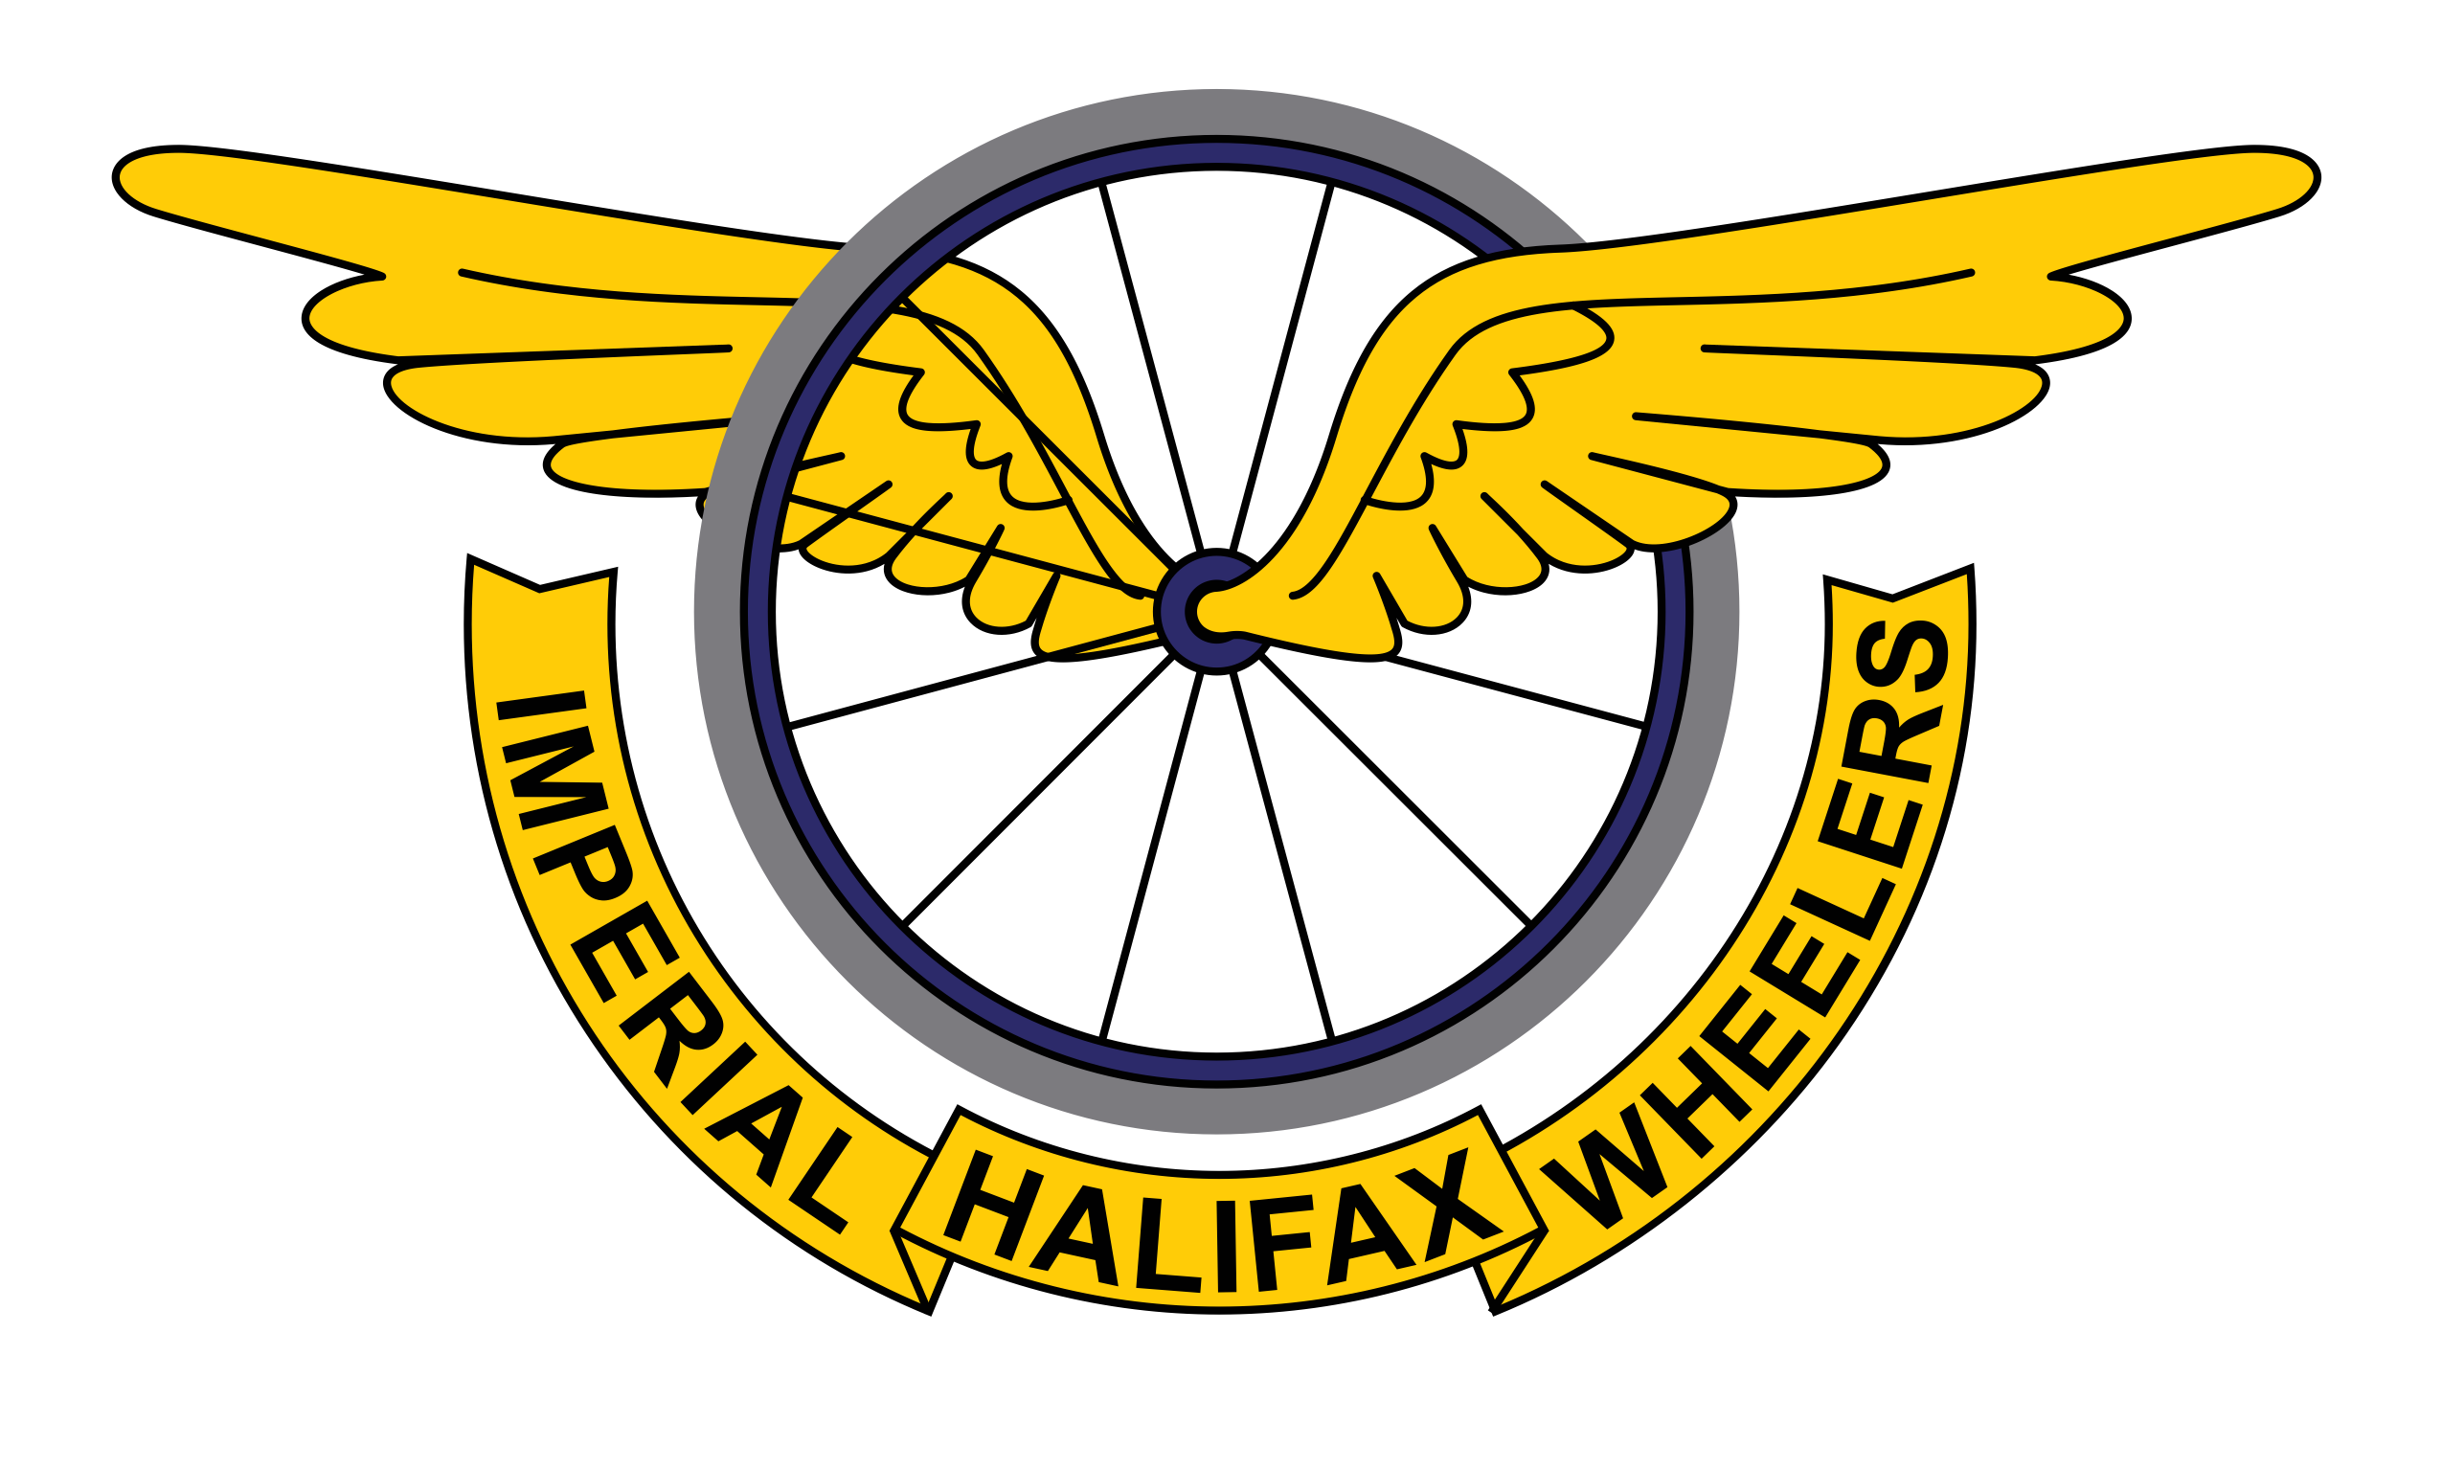

**Female**

1st Female – **Mary Wilkinson**

Holiday at Barend Holiday Lodges

2nd Female – **Jo Blackburn** -£30

3rd Female – **Jo Cebrat** - £15

Vet 40 Female – **Mary Wilkinson** - £30

Vet 50 Female – **Clare Ash** - £30

Juvenile Female – **Elena Green** -£25

Sponsored by Pye Nest Day Nursery

First time female – **Elena Green**

Prizes sponsored by OTE Sports and Triangle Bakehouse

**Male**

1st Male – **Andrew Feather**

Bike Fit from Fit2Ride.cc

2nd Male –**Tom Bell** - £30

3rd Male – **Jude Taylor** - £15

Vet 40 Male - **Andrew Laidler**– £30

Vet 50 Male – **Adrian Thorpe & Andrew Askwith** -£30

Vet 60 Male – **John Flanagan** - £30

Espoir Male- **Daniel Pullen -** £25

Junior Male – **Jack Parnaby** - £25

Juvenile Male – **Patrick Casey** -£25

Sponsored by Pye Nest Day Nursery

First time male – **Jack Parnaby**

Prizes sponsored by OTE Sports and Triangle Bakehouse

Thanks to sponsors, volunteers, photographers and supporters.

Thanks to timekeepers – George Barker and Stephen Brown

Thanks to the weather!

Thanks to everyone who raced for making it such a great morning of racing.

See you in 2022!

**Please support our sponsors if you are able**

**Fastest female and male times across both Imperial Wheelers Events** – prizes sponsored by Mamil Café Bar

**Mary Wilkinson & Tom Bell**

**Lantern Rouge-** **Graham Lloyd** - prize sponsored by Triangle Bakehouse

Ripponden Bank Hill Climb 2021 - Results